Press Release

SIGMA Engineering and Momentive Performance Materials agree on strategic partnership

The aim of the cooperation is to optimize material data for silicone elastomers in order to make process simulation with SIGMASOFT® Virtual Molding even more reliable.

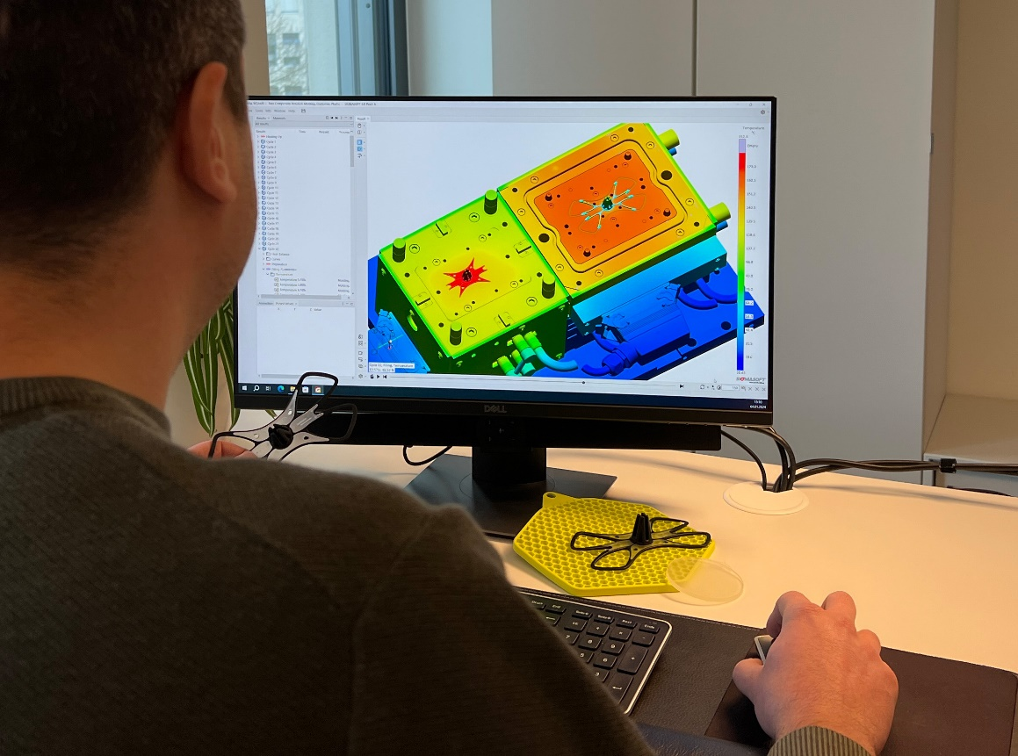

Aachen and Leverkusen, 10.01.24 – The partnership between the world market leader in LSR injection molding simulation and one of the leading manufacturers of silicone and silicone derivatives is good news for the silicone processing industry. The challenge here is to produce high-precision components with high requirements that simultaneously exhibit the highest thermal expansion and the greatest compressibility of all elastomers. The more precise the material data and understanding of the material, the better the predictions made by the simulation. The partnership will offer high added value for this industry thanks to the synergies created.
The use of standardized laboratory values for the definition of material laws in the simulation is not sufficient to describe the complex behavior of components. The observation and consideration of process parameters during processing is not yet part of conventional material data. In future, it will be necessary to use data from real injection molding processing in order to refine and calibrate the material data. This improves the reliability of the simulation results as well as the material data.
Thomas Klein, Managing Director of SIGMA Engineering, is delighted about the partnership and the goals behind it: "Partnerships are formed to create something bigger together and offer added value to the market."
"We are very much looking forward to working together with SIGMA Engineering," says Holger Albrecht, Vice President and Head of the Elastomer Business Unit at Momentive. "The more precise the material data in LSR processing, the more accurate the simulation can be. This is certainly an advantage for companies in the silicone processing industry - because there is potential for far-reaching optimizations in the manufacturing process."

Since 1998, SIGMA Engineering GmbH has been driving the development of the injection molding process with its simulation solution SIGMASOFT® Virtual Molding. This virtual injection molding machine enables the optimization and development of polymer components and molds as well as the mapping of the entire production process. The SIGMASOFT® Virtual Molding technology combines the part’s 3D geometry with its tooling and temperature control system and integrates the parameters of the production process. This ensures a cost-efficient and resource-saving production as well as high-performance products - from the first shot.
SIGMASOFT® Virtual Molding integrates a multitude of process-specific models including 3D simulation technologies that have been developed and validated over decades and are being continuously optimized. The SIGMA Solution Service and Development team support customers’ specific goals with application solutions. The software company SIGMA offers application engineering, training, direct sales, and support. A software straight from its developers and designers to be a solution service to polymer engineering all over Europe.
SIGMA Engineering GmbH, headed by Managing Director Thomas Klein, has subsidiaries in the USA, Brazil, Singapore, China, India, Korea, and Turkey. In addition, SIGMA supports its users worldwide in a variety of international companies and research institutions with its Virtual Molding technology.
More information: sigmasoft.de

About Momentive Performance Materials
Momentive is a global leader in advanced materials with a focus on silicones and specialty products. The company delivers solutions worldwide that help drive its customers' products forward. With every innovation, Momentive creates a more sustainable future. Its extensive product portfolio consists of advanced silicones and specialty solutions that play an essential role in enhancing performance in a variety of industries, including agriculture, automotive, aerospace, electronics, energy, healthcare, personal care, consumer products, construction and many more. Momentive Performance Materials Inc. is an indirect wholly owned subsidiary of MOM Holding Company.

Diese Presseinformation ist zum Download im pdf-Format unter folgendem Link verfügbar:
https://www.sigmasoft.de/en/press/

Contact SIGMASOFT: Contact Momentive:

Katharina Aschhoff Philipp Tönnemann
press@sigmasoft.de philipp.toennemann@momentive.com
+49-241-89495-1008 +49-162-4305899
Kackertstr. 16-18 Chempark Leverkusen
D-52072 Aachen 51368 Leverkusen

