Contact:

Katharina Aschhoff, M.Sc.
press@sigmasoft.de
+49-241-89495-1008
Kackertstr. 16-18
D-52072 Aachen

Press Release

Less is more – SIGMA presents new user-interface

SIGMASOFT® 6.0 release coming up

During 25 years of development the simulation-suite SIGMASOFT® was regularly extended. New possibilities based on new technologies, enhanced options and functionalities made the user-interface more and more complex over the years. A newly designed ergonomic desktop was developed for the current version 6.0. The intuitive usability makes it easier for experts as well as for occasional users, to get to their desired results quicker.

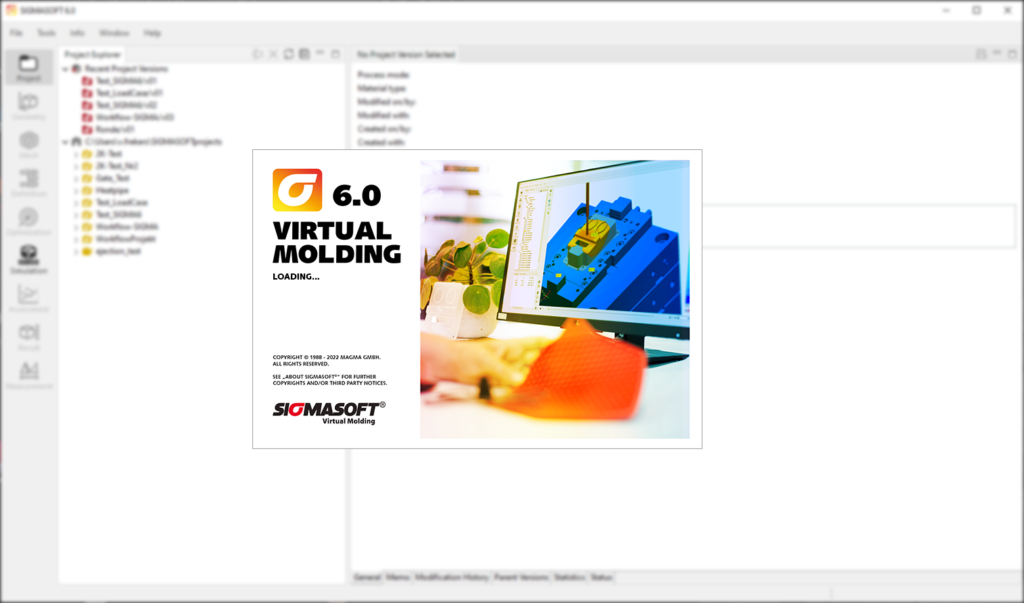
Picture 1 – Less is more – First impression of the new user-interface of SIGMASOFT® 6.0

SIGMASOFT® 6.0 –
faster to success through intuitive user-interface

Aachen, September 1st, 2022 – During K 2022 in Duesseldorf (October 19-26th 2022) SIGMA Engineering GmbH presents the new version of SIGMASOFT® 6.0 at booth B29 in hall 13. Software users want “More of Less” – this summarizes the current challenge in development. The huge number of features and options, which modern CAE software offers, makes it difficult as a user to swiftly find and select the best next step. This results in time-loss and demotivation. Then, actually easy tasks and calculations seem to be difficult without any need.
This is exactly the starting point of the new SIGMASOFT® 6.0. The new user-interface was freed from optional buttons and dead freight. Tools, functions and options dynamically appear in the working area only where and when they are useful. Consistently redesigned and enlarged icons facilitate intuitive usability. Also for occasional users and starters, the hurdle and effort to “quickly simulate something” shrinks considerably.
“It was about time, to adjust our user interface to the newest industry needs. SIGMASOFT® 6.0 not only looks fresh and modern, it also makes the application more intuitive, effective and easier”, says Timo Gebauer, CTO of SIGMA. “All expert-functions, as well as the exotic stuff continue to exist of course. But now they show up on much better places for them. Important is, that the user has only the handful of tools on his desk, that he needs at this moment.”
The new version also includes the latest additions of SIGMASOFT® including Virtual Thermoplastics und Compression Molding, presented to the global expert community in Duesseldorf for the first time.
Since 1998, SIGMA Engineering GmbH has been driving the development of the injection molding process with its simulation solution SIGMASOFT® Virtual Molding. This virtual injection molding machine enables the optimization and development of polymer components and molds as well as the mapping of the entire production process. The SIGMASOFT® Virtual Molding technology combines the parts 3D geometries with its tooling and temperature control system and integrates the parameters of the production process. This ensures a cost-efficient and resource-saving production as well as high-performance products - from the first shot.
SIGMASOFT® Virtual Molding integrates a multitude of process-specific models including 3D simulation technologies that have been developed and validated over decades and are being continuously optimized. The SIGMA Solution Service and Development team support customers specific goals with application solutions. The software company SIGMA offers application engineering, training, direct sales and support. A software straight from its developers and designers to be a solution service to polymer engineering all over Europe.
SIGMA Engineering GmbH, headed by Managing Director Thomas Klein, has subsidiaries in the USA, Brazil, Singapore, China, India, Korea and Turkey. In addition, SIGMA supports its users worldwide in a variety of international companies and research institutions with its Virtual Molding technology.
More information: sigmasoft.de

This press information is available to download as pdf and doc format under the following link: https://www.sigmasoft.de/en/press/

