**Contact:**

Katharina Doetz, M.Sc.

press@sigmasoft.de

+49-241-89495-1008

Kackertstr. 16-18

D-52072 Aachen

**Press Release**

**SIGMASOFT® at DKT 2024**

**New features for elastomer simulation**

*At DKT 2024, SIGMA Engineering introduces the new version of SIGMASOFT® Virtual Molding. The spotlight is on new features specifically for elastomers, such as a new generic elastomer database: SIGMA Rubber Designer.*

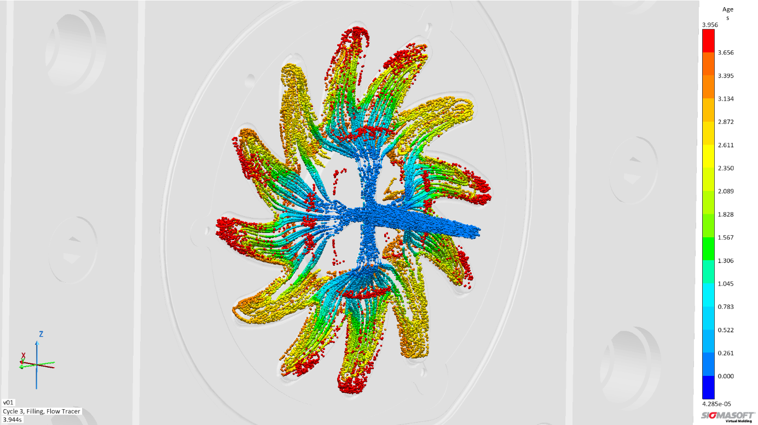

*Picture: “Flowtracers” animate the filling details of the screening star in SIGMASOFT®*

**SIGMASOFT® at DKT 2024**

**Aachen, May 16th, 2024** – At DKT 2024 in Nuremberg (July 1-4), SIGMA Engineering GmbH will showcase the advancements of SIGMASOFT® at booth 9-215. With the new version 6.1.1, new features for elastomer processing become available.

The measurement of elastomers is time-consuming and cost-intensive, which is why the material data of the compounds based on measurements is only available for the simulation in a few cases. This is where the SIGMA Rubber Designer comes in: This generic database allows approximation of the own elastomer compound without measurement, for use in simulation, thereby obtaining realistic results swiftly and efficiently.

In the continuous development of SIGMASOFT® Virtual Molding, research is always at the forefront. The pursuit of improvements and the development or adaptation of new models continuously expands the software's capabilities, especially in elastomer processing, where these extended approaches are required. At the conference, Timo Gebauer, CTO of SIGMA, will present the contribution "Viscoelastic constitutive modeling for flow simulation in injection and compression molding based on log-conformation methods." Although the first rheological models for viscoelastic constitutive modeling were published over 70 years ago, their application in industrial process simulation is still limited. Approaches with state-of-the-art numerical methods based on the log-conformation approach have been developed and implemented in SIGMASOFT® to address further challenges in material characterization and model selection or adaptation.

Together with industry partners, SIGMA will present practical examples of ongoing processes developed with SIGMASOFT®. At the ENGEL stand, the production of a screening star made of NBR and the large-scale production of slit valves made of LSR will be presented. At the SIGMASOFT® booth, explanatory simulation results will be available.

"Our focus is not on our software itself, but on what can be achieved with it," says Thomas Klein, CEO of SIGMA. "We guide our customers, train dozens of simulation experts every year, and are available every day to provide engineering assistance. Especially in the elastomer world, this is of central importance, and we are proud to have been a sought-after partner in this industry network for many years."

Since 1998, SIGMA Engineering GmbH has been driving the development of the injection molding process with its simulation solution SIGMASOFT® Virtual Molding. This virtual injection molding machine enables the optimization and development of polymer components and molds as well as the mapping of the entire production process. The SIGMASOFT® Virtual Molding technology combines the part’s 3D geometry with its tooling and temperature control system and integrates the parameters of the production process. This ensures a cost-efficient and resource-saving production as well as high-performance products - from the first shot.

SIGMASOFT® Virtual Molding integrates a multitude of process-specific models including 3D simulation technologies that have been developed and validated over decades and are being continuously optimized. The SIGMA Solution Service and Development team support customers’ specific goals with application solutions. The software company SIGMA offers application engineering, training, direct sales, and support. A software straight from its developers and designers to be a solution service to polymer engineering all over Europe.

SIGMA Engineering GmbH, headed by Managing Director Thomas Klein, has subsidiaries in the USA, Brazil, Singapore, China, India, Korea, and Turkey. In addition, SIGMA supports its users worldwide in a variety of international companies and research institutions with its Virtual Molding technology.

More information: sigmasoft.de

This press information is available to download in pdf and doc format under the following link: <https://www.sigmasoft.de/en/press/>