Contact:
Aurelia Dogan
Wahid Moorad
press@sigmasoft.de
+49-241-89495-1006
Kackertstr. 16-18
D-52072 Aachen

Press Release

Realistic Simulation of Injection Molding Processes: SIGMASOFT at the IZB
Aachen, September 2026 – This year, SIGMA Engineering will be presenting at the International Suppliers Fair (IZB) in Wolfsburg for the first time. From October 27 to 29, 2026, the company will show at booth 2-2505 how SIGMASOFT® Virtual Molding can be used to virtually map the entire injection molding process and optimize it as early as the development phase. The spotlight will be on the newly released Version 6.2 of the simulation software.
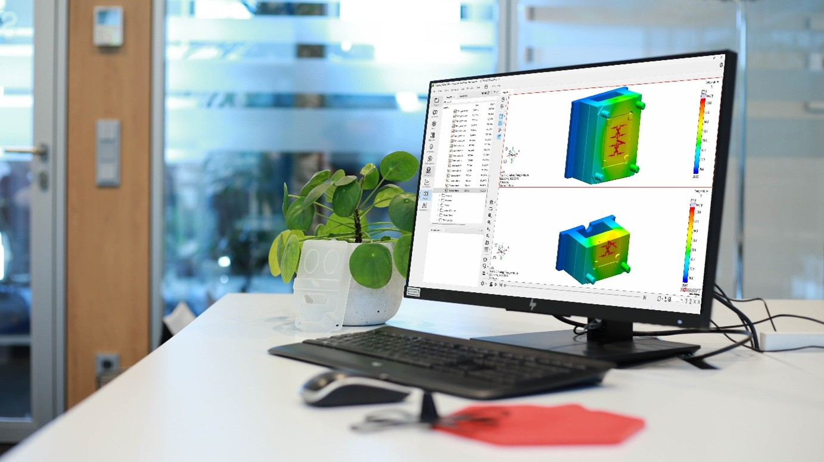Figure 1: Discover new features from the latest SIGMASOFT® 6.2 release
In automotive development, mechanical simulations of components and assemblies have long been established – from the design of individual parts to crash behavior simulation. Detailed simulation of the manufacturing process, however, is far less widespread. Yet many of a component's properties are already determined during injection molding and can significantly influence its later quality and performance. Examples of this include the distribution and orientation of glass fibers, or the location of weld lines or voids/sink marks.
This is where SIGMASOFT® Virtual Molding comes in: the software realistically maps the entire injection molding process for thermoplastics, elastomers, and thermosets through to MIM/CIM. It considers not just the part geometry, but the complete mold including all relevant details. This makes it possible to identify hotspots, weld lines, air traps, and other potential weak points before production even begins, so they can be specifically avoided.
Another advantage: the finished, demolded, and cooled component – including shrinkage and warpage – can also be exported for further simulations. This provides realistic geometry data for downstream mechanical analyses, for example. As a result, development processes can be safeguarded early on, mold corrections reduced, and time and cost planning made more reliable.
"Being part of the IZB is an exciting step for us. We're looking forward to showing, visitors who don't know us yet, the savings potential that lies in their own development and manufacturing," says Thomas Klein, Managing Director of SIGMA. "But also personally saying hello to many of our customers who will be exhibiting there at the same time."

Since 1998, SIGMA Engineering GmbH has been driving improvements in the injection molding process with its SIGMASOFT® Virtual Molding simulation solution. This virtual injection molding software enables the optimization and development of plastic components and molds, as well as the simulation of the entire process control. This is because SIGMASOFT® Virtual Molding technology combines the 3D geometries of the part with the mold and temperature control system and integrates the parameters of the production process. This enables cost-efficient, resource-saving production and high-performance products—right from the first shot.
SIGMASOFT® Virtual Molding integrates a wide range of process-specific models and 3D simulation technologies that have been developed and validated over decades and are continuously optimized. The SIGMA solution and development team supports customers’ technical goals with application-specific solutions. The software company SIGMA offers direct sales, application engineering, training, installation, and a Solution Service provided by engineers throughout Europe.
With subsidiaries of its sister companies in the USA, Brazil, Singapore, China, India, Korea, and Turkey, SIGMA supports users worldwide in a wide range of international companies and research institutions with its Virtual Molding technology.
Further information: sigmasoft.de

This press release is available for download in PDF format at the following link: https://www.sigmasoft.de/en/about-us/press/

