Contact:

Katharina Aschhoff, M.Sc.
press@sigmasoft.de
+49-241-89495-1008
Kackertstr. 16-18
D-52072 Aachen

Press release

SIGMA Technical Talks
A third round of the successful Webinar-Series

The SIGMA Technical Talks have proven themselves well over the past two years. But even today, there is still a need to learn for free and in a time-efficient manner. Therefore, there is a new edition of the webinar series in this spring with new and current topics from the world around SIGMASOFT®.
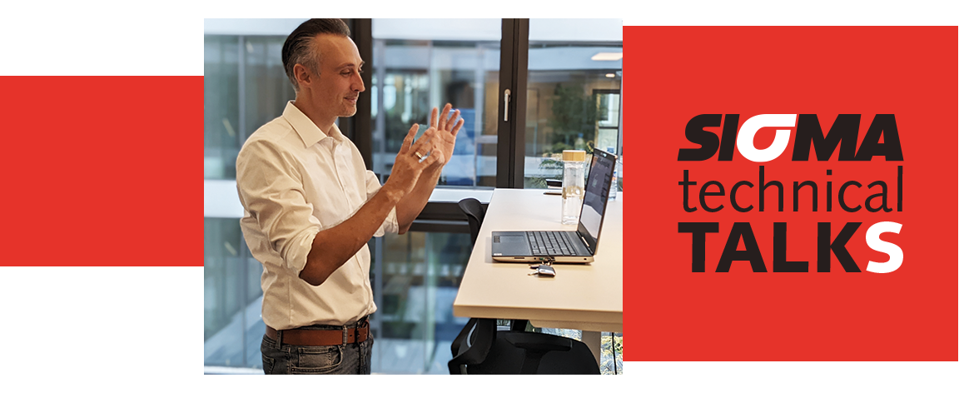

SIGMA Technical Talks
A third round of the successful Webinar-Series
Aachen, Feb 20th, 2023 - SIGMA Engineering is organizing weekly webinars again starting in late February. They are each about 60 minutes long and showcase interesting details and news about SIGMASOFT®. The individual areas of focus are as diverse as the applications of this simulation suite.
The webinar "DoE" demonstrates and discusses systematic virtual experiment planning and its automated execution and evaluation. "Virtual Thermoplastics" covers how more accurate simulation results can be achieved through practical improvement of material laws. The event "Elastomer" focuses on the precise impact of vulcanization on component mechanics, presenting a novel approach. Further insights into MIM (Metal Injection Molding) are provided in the webinar of the same name, enriched by presentations from ARBURG and BASF. All webinars are live events and participants participate with questions.
"The good feedback of the last years has encouraged us to relaunch this series of webinars for professionals," says Timo Gebauer, CTO of SIGMA. "This year, in shorter events, we are presenting individual parts and new possibilities of our software. Our customers - like us - have realized in the last two years that long trips can often be efficiently replaced by a web meeting. Therefore, the SIGMA Technical Talks will continue to be an offer for exchanging with us on technology and innovation."
Participation is free of charge for all interested parties. In addition to technical enthusiasm, only registration is required at www.sigmasoft.de. The dates take place in German and/or English. Events in other languages are already in the calendar."

Since 1998, SIGMA Engineering GmbH has been driving the development of the injection molding process with its simulation solution SIGMASOFT® Virtual Molding. This virtual injection molding machine enables the optimization and development of polymer components and molds as well as the mapping of the entire production process. The SIGMASOFT® Virtual Molding technology combines the part’s 3D geometry with its tooling and temperature control system and integrates the parameters of the production process. This ensures a cost-efficient and resource-saving production as well as high-performance products - from the first shot.

SIGMASOFT® Virtual Molding integrates a multitude of process-specific models including 3D simulation technologies that have been developed and validated over decades and are being continuously optimized. The SIGMA Solution Service and Development team support customers’ specific goals with application solutions. The software company SIGMA offers application engineering, training, direct sales, and support. A software straight from its developers and designers to be a solution service to polymer engineering all over Europe.

SIGMA Engineering GmbH, headed by Managing Director Thomas Klein, has subsidiaries in the USA, Brazil, Singapore, China, India, Korea, and Turkey. In addition, SIGMA supports its users worldwide in a variety of international companies and research institutions with its Virtual Molding technology.
More information: sigmasoft.de

This press information is available to download in pdf and doc format under the following link: https://www.sigmasoft.de/en/press/

