Contact:

Katharina Doetz, M.Sc.
press@sigmasoft.de
+49-241-89495-1008
Kackertstr. 16-18
D-52072 Aachen

Press Release

SIGMAecon

Process simulation enhanced by realistic cost calculation

Until now, simulation results were only measurable – soon, they are also countable. SIGMAecon enables process-dependent cost calculation, thereby providing the opportunity to determine the best compromise between quality, optimal process, and minimal costs.

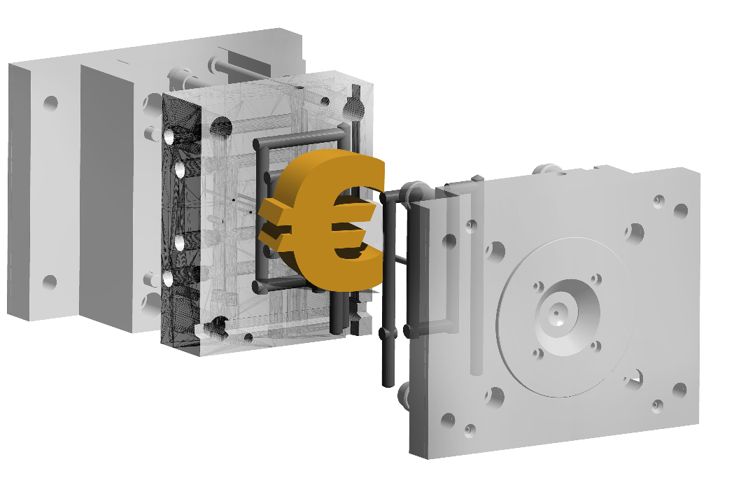

SIGMAecon

Aachen, April 19th 2024 – With the new version SIGMASOFT® 6.1, SIGMA Engineering GmbH releases SIGMAecon among other features. This tool offers the possibility of cost estimation directly combined with simulation results. Thus, the best compromise between quality, process, and costs can be quickly identified, as quality, productivity, and resources are simultaneously considered.
For more than 25 years, professionals have been calculating every detail in the molding process of polymers accurately and reliably with SIGMASOFT® Virtual Molding. In addition to physical results such as pressure, temperature, or time, the new tool SIGMAecon now adds financially quantifiable results.
The detailed knowledge of own production processes and their optimization possibilities is crucial in the increasingly competitive environment. Often even more important is knowing the real manufacturing costs. For instance, is an (assumed) optimization associated with lower costs due to reduced cycle time? Or do costs increase due to higher energy consumption?
Securing a contract often depends on offering an aggressive selling price. However, turning such a project into a sustainable success requires precise knowledge of one's own costs beforehand. During the inquiry phase, SIGMASOFT® allows for quick examination and optimization of several important scenarios. Accurate predictions regarding time, material or pressure requirements, flow diagrams, etc., can then be provided to the pricing calculation as well-founded references.
However, SIGMAecon takes it a step further by allowing the user to precisely determine the component costs of the currently simulated process and its optimization variants. Modified thermal concepts (such as the use of hot or cold runner technology or additional insulation) are not only considered as additional costs or material savings but also in terms of the energy consumption.
"The benefits for our users are clear," says Thomas Klein, CEO of SIGMA. "With SIGMASOFT® Virtual Molding, process optimizations are already possible during the inquiry phase. SIGMAecon assists in decision-making in engineering and strengthens the user as a central source of reliable information, from both technical and financial perspectives."
SIGMAecon includes predefined templates as well as the ability to define all inputs freely. The results are presented in tables or diagrams but can also be evaluated directly from a Design of Experiments (DoE) with SIGMASOFT® for comparing different scenarios. This enables the optimization of manufacturing costs, which are now known in detail at the earliest possible stage.

Since 1998, SIGMA Engineering GmbH has been driving the development of the injection molding process with its simulation solution SIGMASOFT® Virtual Molding. This virtual injection molding machine enables the optimization and development of polymer components and molds as well as the mapping of the entire production process. The SIGMASOFT® Virtual Molding technology combines the part’s 3D geometry with its tooling and temperature control system and integrates the parameters of the production process. This ensures a cost-efficient and resource-saving production as well as high-performance products - from the first shot.
SIGMASOFT® Virtual Molding integrates a multitude of process-specific models including 3D simulation technologies that have been developed and validated over decades and are being continuously optimized. The SIGMA Solution Service and Development team support customers’ specific goals with application solutions. The software company SIGMA offers application engineering, training, direct sales, and support. A software straight from its developers and designers to be a solution service to polymer engineering all over Europe.
SIGMA Engineering GmbH, headed by Managing Director Thomas Klein, has subsidiaries in the USA, Brazil, Singapore, China, India, Korea, and Turkey. In addition, SIGMA supports its users worldwide in a variety of international companies and research institutions with its Virtual Molding technology.
More information: sigmasoft.de

This press information is available to download in pdf and doc format under the following link: https://www.sigmasoft.de/en/press/

